

**METU**

**ELECTRICAL AND ELECTRONICS ENGINEERING DEPARTMENT**

**EE463 – Static Power Conversion I**

**Fall 2021-2022**

**Term Project Simulation Report**

**Judicator Inc.**

**Hüsnü Oğuz YORGANCILAR**  **23**

**Ece İrem YAZIR**  **23**

**Kaan TÜTEK** **2375954**

**To be submitted to: Assoc. Prof. Ozan KEYSAN**

Table of Contents

Introduction 3

Topology Discussion 3

Analytical Calculations 3

Simulations 3

Rectifier 3

Buck Converter 3

555 Timer 3

Overall Circuit 3

Component Selection 3

Thermal Analysis 3

Implementation 3

# Introduction

# Topology Discussion

# Analytical Calculations

# Simulations

## Rectifier

## Buck Converter

With the output of the rectifier fed into the buck converter and the output of the rectifier fed into the DC motor with a terminal voltage limit of 180VDC, the relation between the buck converter input and output demands a careful cap on its main control parameter, the duty cycle. Vs,rms will be assigned 100V as was done in the rectifier simulation.

$$V_{out,buck}={D×V}_{in,buck}$$

$$V_{in,buck}=\frac{3\sqrt{6}V_{s,rms}}{π}≅220V_{DC}$$

$$V_{out,buck}=\frac{3\sqrt{6}×D×V_{s,rms}}{π}≤180V_{DC}$$

$$D≤0.7695$$

However, with the addition of an output capacitor, the average output voltage of the rectifier is expected to increase. This increase can be compensated by decreasing the calculated duty cycle. For now, we will limit D at 0.7. This will be monitored with the potentiometers inside the 555 timer topology.

Even so, a duty cycle of 70% could be fatal to the driver circuit during start-up. DC motors have large inrush currents due to the induced emf being speed dependent:

$$E_{a}=K_{a}K_{f}I_{f}ω_{mech}$$

$$I_{a}=\frac{V_{a}-E_{a}}{R_{a}}$$

The low speed of the motor, coupled with the low armature resistance of 0.8Ω, can lead to very high currents. Considering we are allowed to soft-start the motor by manipulating D over time, we will start the circuit with a 10% duty cycle and measure the voltage and current maxima displayed over the components. This will help us simulate the worst-case scenario in terms of currents and determine the limiting metrics. We will replicate the DC motor as an RL branch in series with Ea=0.05V.

The buck converter won’t have an LC filter at its output due to the motor acting as an RL load itself. The switching component was selected to be an IGBT due to its superior current-voltage limits. The input was provided as 220VDC.

The frequency of operation was registered in the pulse generator block as 1kHz. The pulse generator represents the 555 timer output.

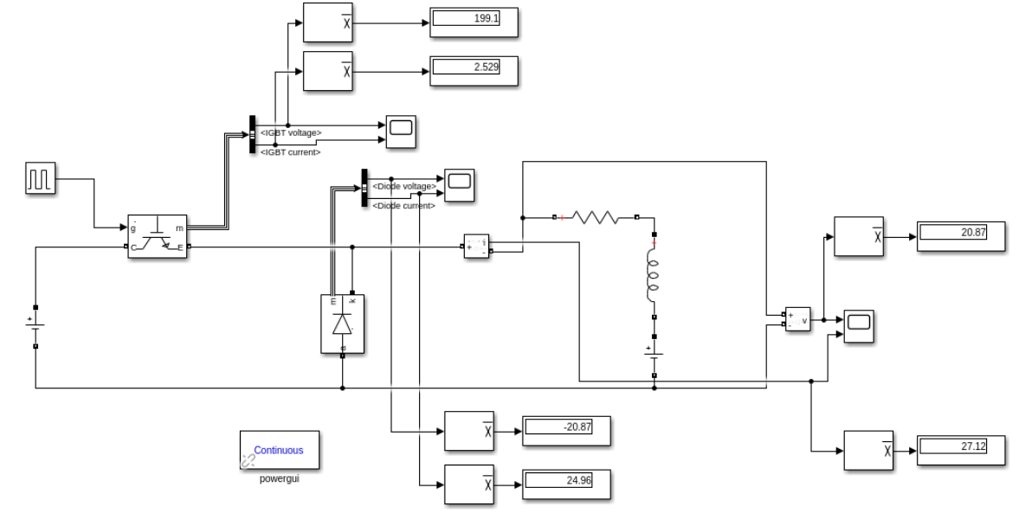

Figure x. Standalone buck converter model at D=0.1 in Simulink.

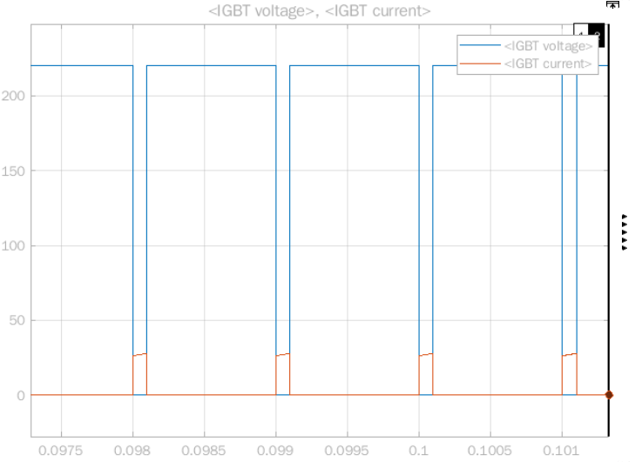

Figure x. IGBT voltage and current waveforms at D=0.1 in Simulink.

An average voltage of 199.1V and an average current of 2.529A was recorded on the IGBT for D=0.1.

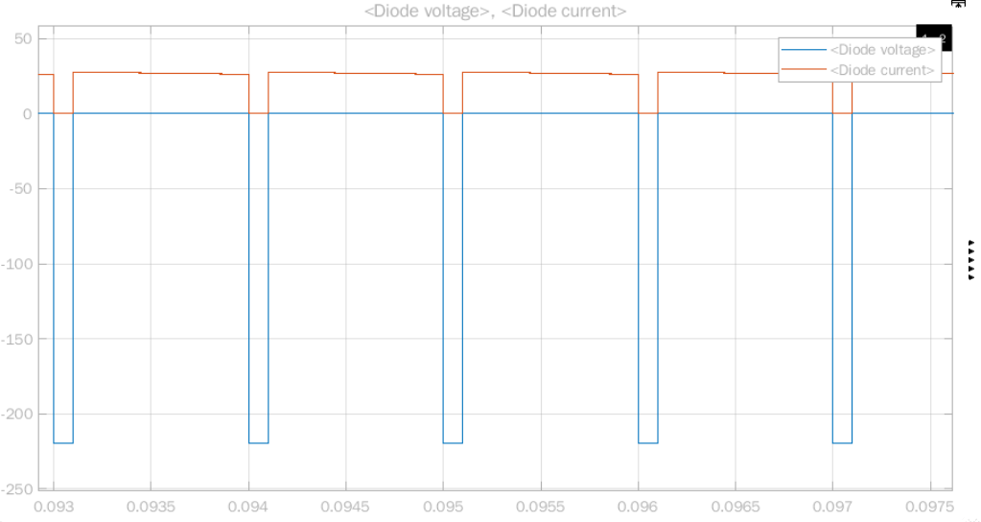

Figure x. Freewheeling diode voltage and current waveforms at D=0.1 in Simulink.

An average voltage of -20.87V and an average current of 24.96A was recorded on the freewheeling diode for D=0.1.

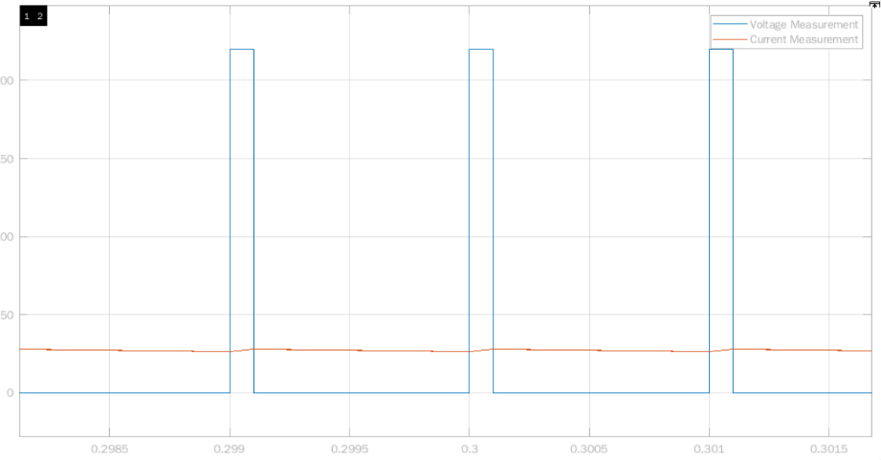

Figure x. Output voltage (Va) and current waveforms (Ia) at D=0.1 in Simulink.

An average voltage of 20.87V and an average current of 27.12A was recorded on the DC motor for D=0.1.

Providing a safety margin of +10%, the set of waveforms for D=0.1 place the following constraints:

|  |  |  |
| --- | --- | --- |
|  | Current rating | Voltage rating |
| IGBT | 3A | 210V |
| Freewheeling diode | 30A | 25V |

Figure x. Output voltage (Va) and current waveforms (Ia) at D=0.1 in Simulink.

It is expected that the IGBT current and diode voltage ratings will have to increase for the D=0.7 simulations, with the increase in the on-time of the circuit.,

With the duty increased to 70%, we will assume the motor has now sped up to its rated value of 1500rpm.

## 555 Timer

## Overall Circuit

# Component Selection

# Thermal Analysis

# Implementation